42.24: Equation (42.13) may be solved for 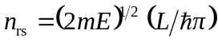, and substituting this into Eq. (42.12), using 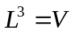, gives Eq. (42.14).

